# 

OPERATION DOCUMENT TITLE

Installing and supporting the solution

Document information

Document version

Approval List

Confidentiality Rating

General

Architecture Overview

Installation Manual

Operation Manuel

Troubleshooting guide

Traceability Matrix

# Document information

## Document version

|  |  |  |
| --- | --- | --- |
| Version | Author e-mail | Description |
| 1.0 | trlb@kea.dk | Initial draft |
|  |  |  |

## Approval List

|  |  |  |
| --- | --- | --- |
| Who | Function | E-mail |
| Nikolaj B. Hemmeshøj | Head of Enterprise Architecture | nibh@kea.dk |
| Jarl Tuxen | Chief Information Security Officer | jart@kea.dk |

## Confidentiality Rating

|  |  |
| --- | --- |
| Rating |  |
| Company Confidential | X |
| Non Confidential |  |

# General

General description of solution at a high level (very short).

# Architecture Overview

Description of components involved and drawing of architecture

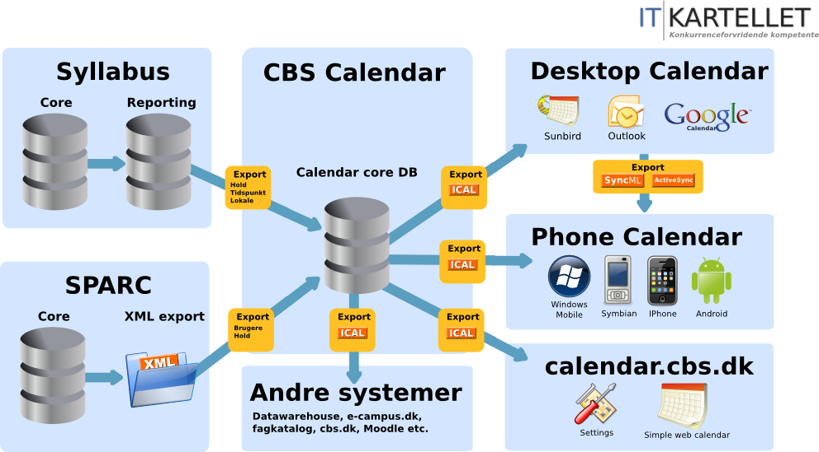

# **Requirements**

**Internet browsers:**

Due to our application being a Graphical User Interface application (GUI) then there is no need our application to support any web browsers.

**Internet Connection:**

Our application runs over the host’s local area network (LAN) connection. Therefore, there is no need for an internet connection to be present for the application to work.

**Operating Systems:**

Our application is supported by the following operating systems:

1. Windows Vista, 7, 8 and 8.1
2. Mac OS X
3. Linux

**Hard Drive:**

There is no specific requirement for the hard drive.

**RAM:**

Since our program is designed for 2-50 users the RAM requirement for the application is 4 GB, so the program will run smoothly.

**CPU:**

Pentium or newer

**MySQL Workbench**

MySQL Workbench is not required to be installed on the system in order to run a MySQL Server but MySQL Workbench is a great tool to use in addition to monitoring database connections on your server. When installing MySQL Workbench there are however some requirements that need to be fulfilled before it will run on your system. Depending on your operating system then the requirements are as follows:

1. ***Windows***

* Microsoft .NET 4.0 Framework (If needed – download available [here](http://www.microsoft.com/en-us/download/details.aspx?id=17851))
* Microsoft Visual C++ 2013 Redistributable Package (MSVC2013) (If needed - download available [here](http://www.microsoft.com/en-us/download/details.aspx?id=40784))
* Windows 7 or above

1. ***Linux and Mac OS X***

* The requirements for Linux are embedded within their respective packages. Use the platform specific tool (for example, yum or apt) to install the package and their dependencies.

# **Installation Manual**

**Development Environments**

We used Eclipse Luna IDE for Java developers.

**Step 1:** Download Eclipse Luna IDE for Java developers [here](https://www.eclipse.org/downloads/packages/eclipse-ide-java-developers/lunasr2)

* Download the zip file to the desktop to ensure easy access

**Step 2:** Extract

* Extract the Eclipse zip file to the desktop

**Step 3:** Finished

* To use Eclipse, access the folder and double click the eclipse application exe

Additionally we used MySQL Connector/J for development but this will be installed with the MySQL Installer on Windows and should be contained in the repository packages for Linux. However will need to be manually installed on Mac OS X.

Download for MySQL Connector/J can be found [here](http://dev.mysql.com/downloads/connector/j/)

**Step 1:** Download MySQL Connector/J for your corresponding operating system

**Step 2:** Double click the install icon

In order to run the KEA_Stud Chat Messenger application, the hosting computer will need to have a MySQL server installed due to the application’s need to connect to a database to store usernames and passwords. Furthermore, the purpose of this manual is to provide the operations team with a simple way of installing said MySQL server onto the hosting computer depending on the computer’s operating system.

*Note: Username and password for the database are the default settings in the KEA_Stud Chat Messenger i.e. meaning, Username = root and password is left empty*

The methods of installation of the MySQL server depends on your operating system and are as follows:

**Windows**

There are three ways to install the MySQL server on Windows.

***MySQL Installer***

This is the full installation package and features all of the MySQL products into one installation. It is recommended to use this installation method if one is more inexperienced with configuring databases, because this will install every product/component needed to maintain server/database connections and in addition configure the server/database during the installation process.

**Step 1:** Download the MySQL Installer – available [here](http://dev.mysql.com/downloads/windows/installer/)

**Step 2:** Double-click the installer icon.

* Once this is done, you will be prompted with a license agreement.

**Step 3:** Select an appropriate setup type for depending on the system.

* ***Developer***: Install all products needed to develop applications with MySQL. (Recommended choice and the default system setup for the application)
* ***Server only***: Only installs the MySQL server.
* ***Client only***: Only installs the MySQL client products, this does not include the MySQL server.
* ***Full***: Install all MySQL products.
* ***Custom***: Manually select which MySQL products to install.

Once an setup has been selected - click next.

**Step 4:** System check

* The installer will now check the system to see whether it fulfills the requirements for certain products or not[1].
* When finished, the installer will present a list of products to be installed.
* Click execute.

**Step 5**: Server Configuration type

* After the products have been installed, a configuration window is displayed (if it is required – given the circumstances, it is expected that this will be the first installation instance on the system and therefore will display this window).
* Here you are asked to select which server configuration type the system will have:
  + **Developer**: A system, which will host many other applications. This could be your personal laptop/desktop. This option will use the least amount of memory.
  + **Server**: Multiple other applications will be running on this system. This option will use a medium amount of memory.
  + **Dedicated**: A system, which will be dedicated to running the MySQL server. This option will use all available memory on the given system.

Once a desired configuration type has been chosen, move to connectivity.

* + The KEA_Stud chat messenger uses the default settings.
  + Click next.

**Step 6:** Account

* You are to determine an account for the server.
  + *Optional:* If there are to be more than one admin on the server, you can add this user.
* Once finished - click next.

**Step 7**: Windows Service

* Windows Service details are to be determined. Such as service name, if the server should start up with the system and how the server is executed.
* Once finished – click next.

**Step 8**: List of configurations displayed

* A window that lists the configurations steps will now be displayed.
* Once reviewed and certain of the settings - click execute.

Done. Your MySQL server is now configured and ready for use.

For the next two methods of installing the MySQL server and Workbench. We will not being going in depth with these because they are self-explanatory and we recommend the previous method for a simple way to install the MySQL Server and MySQL Workbench.

***Web-community installer***

The web-based installer will contain the installer and configuration files that are needed to run a server as well as allow the user the freedom to select which products to install on the system.

Download available [here](http://dev.mysql.com/downloads/windows/installer/)

***Installing each product separately***

This is an option where each product will be downloaded using its standalone package and installed via said package. This is an option for the more experienced users, because this will involve manual Database/Server configuration.

Downloads available at:

* [MySQL Server](http://dev.mysql.com/downloads/mysql/)
* [MySQL Workbench](http://dev.mysql.com/downloads/workbench/)
* [Connectors](http://dev.mysql.com/downloads/connector/)

**Linux:**

For Linux there are two methods of installing the MySQL Server. By repository packages or by installing the products separately. Furthermore, the procedures for the installation are different depending on the Linux distribution in which the system uses.

***Repository Packages***

There are two different repository packages, Yum and APT. Each repository supports a different distribution.

***Yum Repository***

**Step 1**: Download the Yum repository

* Download Yum repository [here](http://dev.mysql.com/downloads/repo/yum/).
* Select and download the package for your distribution.
* Install the package with the following command: ***shell> sudo rpm -Uvh platform-and-version-specific-package-name.rpm*** (replace ***platform-and-version-specific-package-name*** with the name of the package)

**Step 2**: Install MySQL with Yum

* Install MySQL with the following command: ***shell> sudo yum install mysql-community-server***. This will install the package for the MySQL server.
* You can also install other products by specifying the product’s name in the command line (example: ***shell> sudo yum install mysql-workbench****)*

***APT Repository***

**Step 1:** Download the APT repository

* Download APT repository [here](http://dev.mysql.com/downloads/repo/apt/).
* Select and download the package for your distribution.
* Install the package with the following command**: *shell> sudo dpkg -i /PATH/platform-and-version-specific-package-name.deb*** (replace ***platform-and-version-specific-package-name*** with the name of the package. Along with its path, if you are not running the command within the same folder in which the package is contained in).

**Step 2**: Install MySQL with APT

* Install MySQL with the following command: ***shell> sudo apt-get install mysql-server***. This will install the package for the MySQL server along with packages for the client and database.
* During the installation process, you will be asked two questions
  + Supply a root password for your MySQL Server
  + If you want to install a test database – select no.

***Installing each product separately***

This is an option where each product will be downloaded using its standalone package and installed via said package.

Downloads available at:

* [MySQL Server](http://dev.mysql.com/downloads/mysql/)
* [MySQL Workbench](http://dev.mysql.com/downloads/workbench/)
* [Connectors](http://dev.mysql.com/downloads/connector/)

***Mac OS X:***

For Mac OS X you will have to install each product separately

***MySQL Server***

**Step 1:** Download the MySQL Server package installer – download is available [here](http://dev.mysql.com/downloads/mysql/)

**Step 2:** Double-click the installer icon.

* Once this is done, you will be prompted with an introduction dialogue – click continue.
* A license agreement is now shown – click continue then agree

**Step 3:** Installation Type

* You will now be able to choose which installation type you want to install
  + **Install:** This will perform a full installation using default settings (recommended)
  + **Customize:** This will allow you to choose which components that are to be installed
  + **Change Installation Location:** This can change the installation type or location

**Step 4**: Click install

Done. A message with a brief summary will be shown on the display, and after closing the installer, you can now use your MySQL Server.

***MySQL Workbench***

**Step 1:** Download the MySQL Workbench package installer – download is available [here](http://dev.mysql.com/downloads/workbench/)

**Step 2:** Double-click the installer icon.

* You will now be shown the installation window

**Step 3:** Drag the MySQL Workbench icon onto the applications icon

Done. Your MySQL Workbench is now installed.

***MySQL Connector***

**Step 1**: Download the MySQL Connector called ODBC – available [here](http://dev.mysql.com/downloads/connector/odbc/)

**Step 2:** Double-click the installer icon.

Done. The MySQL ODBC Connector is now installed

# Operation Manuel

How to start up/shut down system.

How to back up, get to log files etc.

# Troubleshooting guide

How to solve problems.

FAQ

When A happens, do B.

# Traceability Matrix

Bi-directional traceability of Requirements to Code.

1. Check page xx for more information regarding requirements